VERSION 1.0 rEVIEWED BY KUNAL NYAYNIT

vaishnavi kandur

 BJ’s Restaurant

MSTR INTEGRATION WITH RSTUDIO

2023

**RStudio Integration with MSTR**

**Introduction:**

MicroStrategy with RStudio offers several benefits by leveraging the powerful data science capabilities of R along with MSTR's visualizations. This collaboration allows organizations to perform advanced statistical analyses, create custom visualizations, and develop sophisticated over the predictive models. As a result, users can extract deeper insights from their data, make more informed decisions, and uncover valuable opportunities for the organization.

As shown in the below picture data scientists have easy access to the trusted  MicroStrategy data. They can import the reliable data into RStudio and export their findings back into MicroStrategy to make it easy to consume.

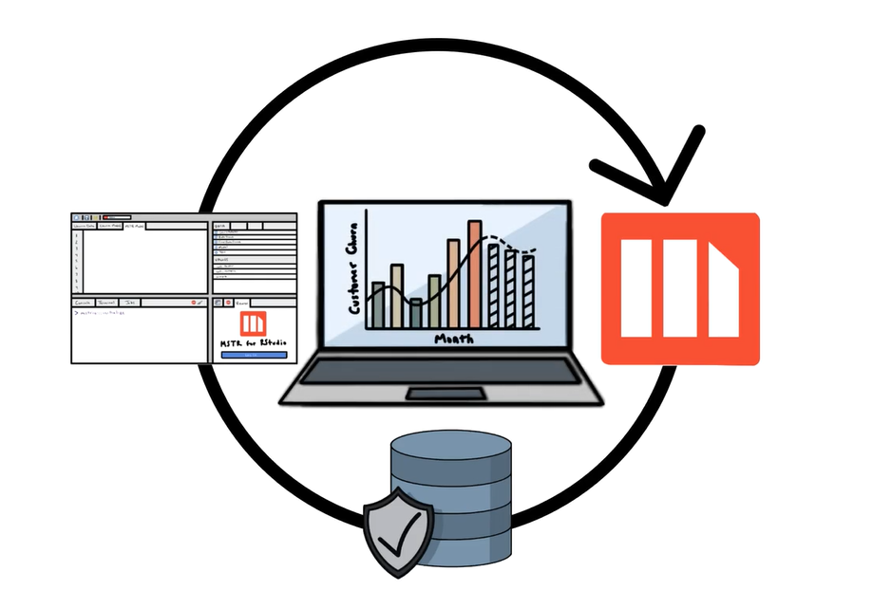

# **System Pre-requisites:**

**MicroStrategy 2019 Update 4 (11.1.4)+** :

* Memory – 4GB or higher
* 15 GB or more of disk space

**RStudio and R**:

* An Intel-compatible platform running Windows 11, 10 /8.1/8 /7 /Vista /XP /2000 Windows Server 2022, 2019 /2016 /2012 /2008 /2003
* At least 256 MB of RAM, a mouse, and enough disk space for recovered files, image files, etc.
* The administrative privileges are required to install and run R‑Studio utilities.
* A network connection for data recovering over network.

**Installations:**

**R**

* R 3.6.0+ should be installed on the system , for downloading R latest version refer to the following link [R-4.3.1 for Windows](https://cran.r-project.org/bin/windows/base/)

**MicroStrategy**

* MicroStrategy 2019 Update 4 (11.1.4)+ [ Download mstrio 10.11.1 from the [CRAN package archive](https://cran.r-project.org/src/contrib/Archive/mstrio/) if you want to use it with MicroStrategy versions earlier than 11.1.4].

**MicroStrategy for RStudio**

* [RStudio Desktop 1.2.1335+](https://posit.co/download/rstudio-desktop/) should be installed on the system
* Settings to install mstrio package :

1. Cross-Origin Resource Sharing (CORS) should be enabled from library Administrator to allow web application running in one origin (domain, protocol, and port) to access selected resources from a server in a different origin , for more details refer to the following link [CORS enabled on MicroStrategy Library server](https://microstrategy.github.io/embedding-sdk-docs/config/#enable-cross-origin-resource-sharing-cors)
2. Make sure that Cookies sent by MicroStrategy Library server have SameSite parameter set to ‘None’. Session cookies must be explicitly marked with SameSite=None; Secure for Embedding SDK to perform as intended in a third-party context

**Mstrio package:**

* Run the following command in RStudio to install mstrio package

install.packages("mstrio")

* After installation the mstrio package in RStudio, the addin for mstrio will automatically be installed in RStudio. If addin is not automatically installed you can browse to following path: *tools->add-ins->Browse add-ins* and install MicroStrategy for RStudio addin

**Exploring Main features of R with MSTR**

Given below are the high level steps:

1. Connecting to MicroStrategy environment
2. Importing data
3. Data cleaning in RStudio
4. Use machine learning models on Dataframes
5. Export Data back to MicroStrategy
6. Update, replace, or append new data to an existing Dataset
7. **Connecting to MicroStrategy environment**

There are two ways to connect to MSTR environment:

Connecting MSTR with RStudio

Using Addin for MicroStrategy within RStudio

By writing R code in RStudio

1. Using Addin for MicroStrategy and RStudio

After installations, you can launch MicroStrategy for RStudio from the adins menu and a window will appear on bottom right corner of the screen, enter the credentials and login to view existing datasets and reports

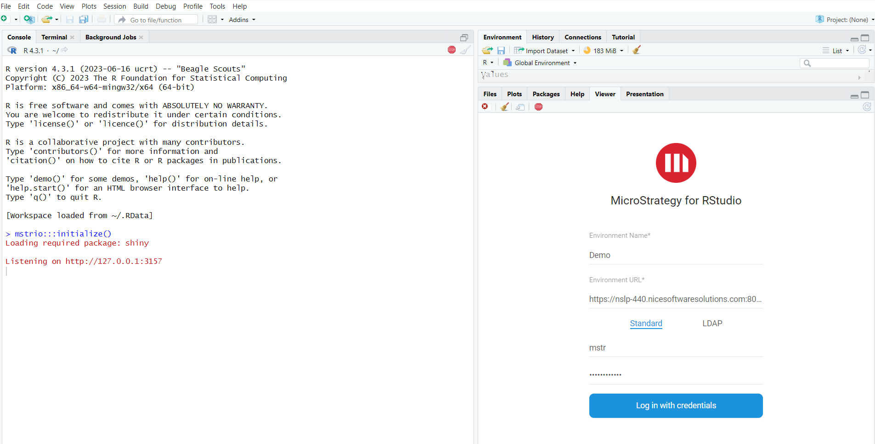

.

1. By manually creating a conns object in R

Using mstrio library, a new instance of the Connection class from the "mstrio" package is created and initialized with the provided connection details. This connection object can then be used to interact with the MicroStrategy Library server.



We can manage the connection object created with help of following inbuilt functions:For more details please refer to the [GitHub documentation](https://github.com/MicroStrategy/mstrio) .

1. **Importing data from a Report or Cube into an R Data Frame**

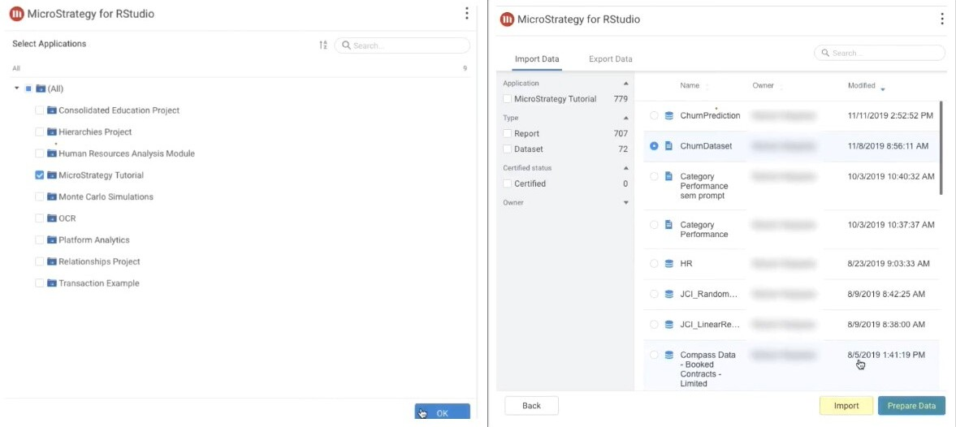

Follow the steps below to import data from MicroStrategy:

1. Select the MicroStrategy projects to display the datasets and reports available for import.
2. Select OK.
3. Choose the data to import from the Import Data tab.
4. Click Prepare Data.
5. Choose the metrics, attributes, and filters you want to use on your data before importing it.
6. Click Import then OK.
7. **Data cleaning in RStudio**

After the data is imported in Rstudio, we will comb through data, clean it up and modify it to ensure the data types work with our model in R. Once the data is cleaned, it can be loaded into machine learning models for better predictions and insights

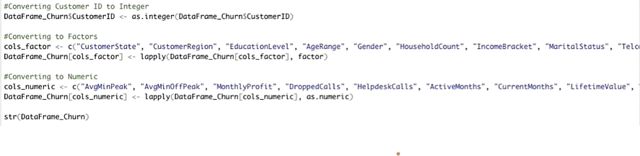

1. **Use machine learning models on Dataframes**

Next step after data cleaning is splitting the data into testing and training data to determine accuracy of our predictive model. Later , we can analyze the quality of our model and deploy the predicted results back to MicroStrategy datasets or reports .

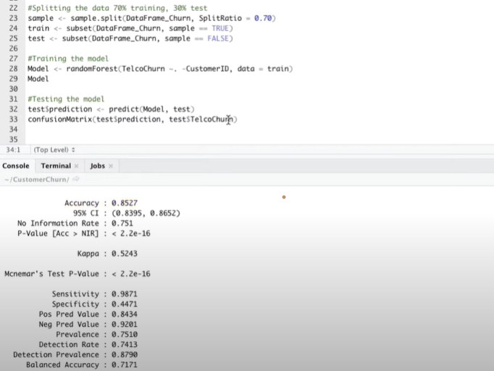

1. **Export Data back to MicroStrategy**

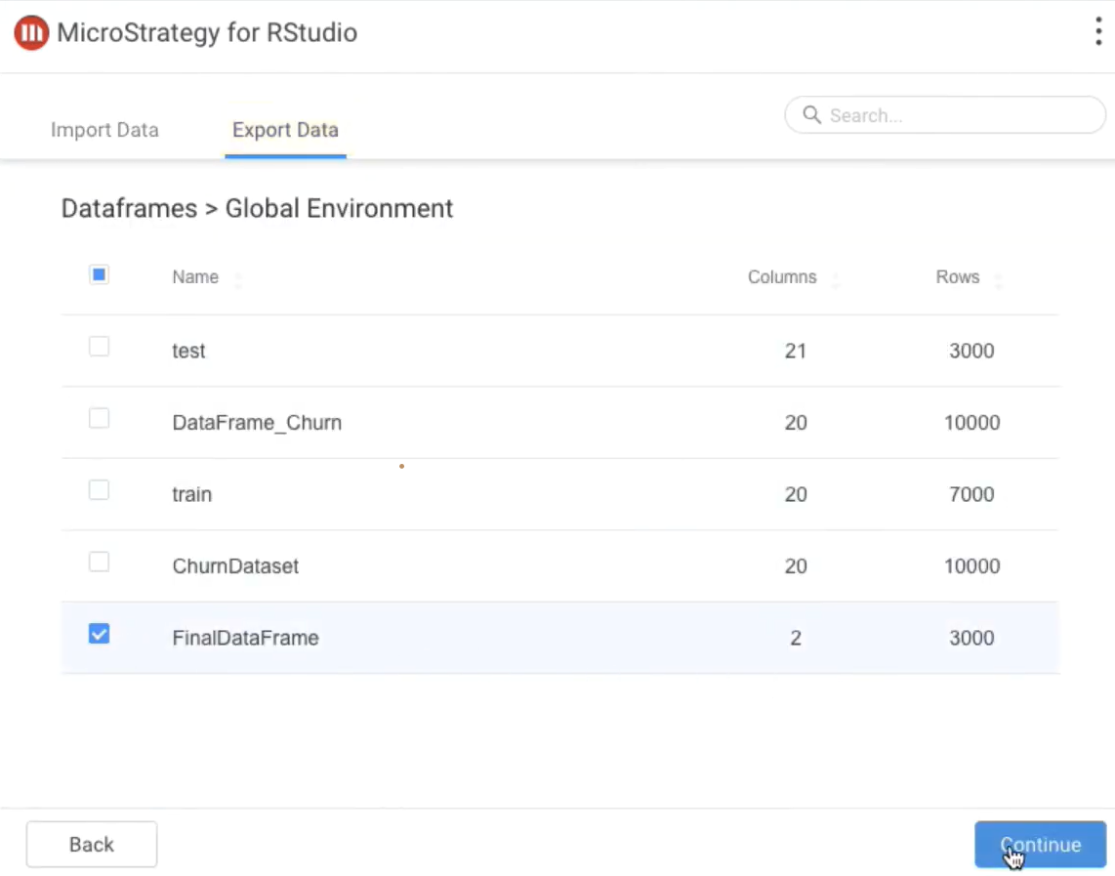

1. Click Create in the Export Data section.
2. Choose the Dataframes you want to export from the Available Dataframes tab
3. Choose which metrics and attributes to export, click next.
4. Give the dataset a name in the Save as field.
5. Browse to the destination folder or click new folder to create a destination for the export.
6. Selecting the Certify checkbox will certify the dataset.
7. Click on Save.
8. **Update, replace, or append new data to an existing Dataset**

Our modelled data structure must correspond to the structure of the cube we are updating. Follow the steps below to update existing dataset or report

1. In the Export Data tab, select the dataset to update.
2. Click Update**.**
3. In the Available Dataframes panel, select Dataframes to update your dataset with. Click Next
4. From the Update Policy drop-down, choose ADD, UPDATE, UPSERT, or REPLACE for each Dataframes.
5. Click PublishandSave**.**